## Sheets (SFO Project Browser)

Fill in the ‘Sheet Series’ and ‘Sheet Type’ parameters when creating new sheets. Placing new views onto sheets immediately after the view has been created aides in sorting and deleting any unused views in the Project Browser.

Sort sheets in the project browser using the “SFO Sheet Browser” definition. This custom organization uses the shared parameters “Sheet Series” and “Sheet Type” to group the sheets according to the sheet series they belong to and the sheet type abbreviation. Refer to the SFO Sheet Numbering standards for information on these parameter values.

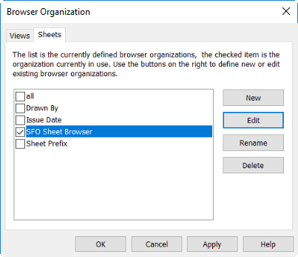

Figure 4.2‑1 SFO Custom Sheet Organization Definition